SMART WATER FOUNTAINS

**Introduction**

Today, more people around the world have pets than ever before. According to American Pet Products Association’s survey in 2020, 67% of U.S. households own a pet which is about 84.9 million homes. This proportion has been increased by 20% in thirty years. Breakdown of the pet types, cats and dogs are the most popular animals, they contribute to about 80% of all pets. Same trend happens all over the world. On average, one in three households own a dog globally and about a quarter of households worldwide own a cat. Both cats and dogs prefer flowing water. A source of fresh clean running water can encourage pets to drink. Drinking a certain amount of water daily plays an important role in long-term health for pets, especially cats. As a result, a water fountain is essential to most households having cats or dogs as pets. However, we cannot ensure the water quality when we are away from home for several days. It can happen when pets have finished all remaining water in the water fountain, or water has been polluted somehow by the pet. These can cause the pet to be unwilling to drink water from the fountain.

**ABSTRACT**

In an increasingly interconnected world, the convergence of technology and everyday life has given rise to innovative solutions aimed at enhancing our overall well-being. Smart water fountains represent one such advancement, transforming the way we access and consume water. This abstract delves into the concept and implications of smart water fountains as a progressive approach to redefining hydration. Smart water fountains leverage cutting-edge sensors, connectivity, and data analytics to provide users with a seamless and personalized drinking experience. These fountains are equipped with sensors that monitor water quality, temperature, and flow rates in real-time. By analyzing this data, users can make informed choices about their hydration, ensuring access to safe and refreshing drinking water. Furthermore, smart water fountains integrate connectivity options, allowing users to access them remotely through smartphone applications or web interfaces. This enables features such as scheduling water breaks, tracking daily water intake, and receiving alerts for filter replacements. Such functionalities promote healthy hydration habits, addressing the growing concern of inadequate water consumption in modern lifestyles. As smart water fountains continue to gain traction, research into their impact on health, sustainability, and user behavior becomes increasingly essential. This abstract highlight the transformative potential of smart water fountains and underscores the importance of their integration into our daily lives for improved health and environmental sustainability in the digital age.

**DESIGN:**

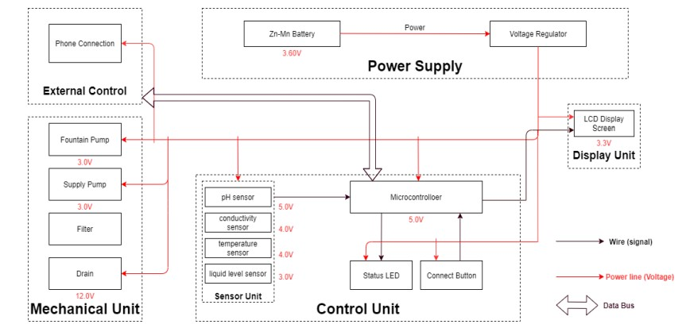

The block diagram below is a general design of our solution. We divide our design into four modules, including Power Supply, Control Unit, External Control, and Mechanical Unit. Details of each unit is presented in the diagram and described in the next section.

**Sensor Unit**

This block contains the four sensors. The data acquired from the sensors will be transmitted to the control unit. Control unit will then have some logic designed to send corresponding signals to control other blocks of the water fountain. At the same time, the display screen on the water fountain will display the readings along with the determined water quality level and remaining water quantity. For the PH-value sensor, temperature sensor and conductivity sensor, values will be retrieved and calculated to determine the overall water quality level. When poor water quality is determined, the water replacement procedures will take place. The weight sensor readings will be used to determine the amount of fresh water left in the water tank. **Temperature Sensor:** A water-proof temperature sensor is going to be used. Part number from sparkfun. This temperature sensor is compatible with a relatively wide range of power supply from 3.0V to 5.5V. The measured temperature ranges from -55 to +125 celsius degrees. Between -10 to + 85 degrees, the accuracy is up to +-0.5 degrees. This sensor can fulfill all requirements needed for this project.

**PH-sensor:** PH value is a valued indicator of water quality. This PH-sensor works with 5V voltage, which is also compatible with the temperature sensor. It can 6measure the PH value from 0 to 14 with an accuracy of +- 0.1 at the temperature of 25 degrees. 2.1.3 Conductivity sensor: Conductivity sensor is also part of the water quality assessment. The input voltage is from 3.0 to 5.0V. The error is small, +-5%F.S. The measurement value ranges from 0 to 20 ms/cm which is enough for water quality monitoring.

**Liquid Level Sensor:** This sensor [9] is responsible for reflecting how much freshwater is left in the water tank. When the water level is low, fresh water will be pumped to the water tank to ensure the water fountain keeps running with freshwater. This sensor is 0.5 Watts. For water level from 0 to 9 inches, the corresponding sensor outputs readings from 0 to 1.6. From that, the quantity of freshwater left can be determined.

**Mechanical Unit Block:** This is very challenging and extremely important. As most of the components will be exposed to water. Sensors, pumps, filters, draining system motors are all to be placed in the water tank. This means that we need to ensure no water can leak into the electrical-related mechanical parts. This puts pressure on the design and also the implementation. In addition, the motor-controlled valves used to drain the polluted water need to be firm when closed. Otherwise the fresh water will be leaking to the polluted water storage and the water consumption will be uncontrollable. To achieve those points, we will make sure the designs are carefully implemented. The actual building process for the container should be proved before placing the electronic parts

**RELATED IMAGES**



**CONCLUSION**

In conclusion, smart water fountains represent a pivotal convergence of technology, health, and sustainability. These innovative devices empower individuals to make informed decisions about their hydration, promoting healthier lifestyles by tracking water intake and ensuring access to safe, refreshing water. Moreover, they contribute to reducing plastic waste and enhancing water conservation efforts, aligning with broader environmental goals.

The integration of smart water fountains into public spaces, educational institutions, and workplaces fosters a culture of well-being, environmental responsibility, and data-driven decision-making. As these fountains continue to evolve and gain widespread adoption, their potential impact on individual health, community sustainability, and water resource management becomes increasingly evident.

To fully realize the benefits of smart water fountains, ongoing research, development, and implementation are essential. By embracing this technology and its multifaceted advantages, we can move closer to a future where hydration is not only smarter but also more sustainable and health-conscious. In doing so, we take a significant step toward improving our quality of life while safeguarding the planet's precious resources.

**THANK YOU**